Summer Menu 2019

North Fork Strawberry Blonde $13.50
LIV Potato Vodka, Strawberry Sorbetta, Organic Lemonade
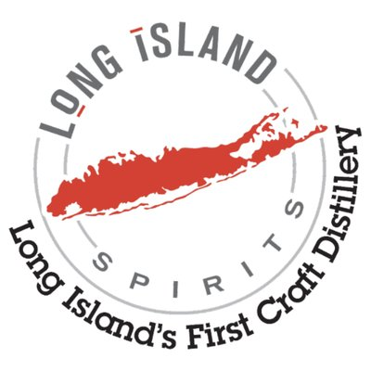
Long Island Sound $13.50
LIV Potato Vodka, Butterfly Tea Syrup, Orange Liqueur, Fresh Lime Juice
Cucumber-Mint Cooler $13.50
LIV Standard Edition Vodka, Cucumber Mint Infused Organic Lemonade
Gourmet Bloody Mary $13.50
LIV Potato Vodka, Holy Schmitt’s Horseradish, Long Island Spirit’s House made Spice Blend
Vanilla Latte $13.50
LIV Ristretto Espresso Vodka, Vanilla, Simple Syrup, Half and Half
Baiting Hollow Mule $22
LIV Potato Vodka, Muddled Limes, Ginger Beer
Gin & Tonic $13.50
Deepwells Botanical Dry Gin and Fever Tree Tonic
Tropical Tea $15
Pineapple Infused Rough Rider Bourbon, Brewed Tea, Brown Sugar Simple Syrup
Sound Avenue $15
Rough Rider Bull Moose Rye, North Fork Absenthe, Aromatic Bitters, Simple Syrup, Lemon Twist
Teddy’s Old Fashioned $15
Rough Rider Bourbon, Muddled Orange and Cherries, Aromatic Bitters, Simple Syrup
Barrel Aged Gin Sour $15
Pine Barrens Barrel Aged Gin, White Vermouth, Lemon Juice, Elderflower Tonic, Simple Syrup
Hi-Rye’s Manhattan $19
Rough Rider Big Stick Rye, Sweet Vermouth, Aromatic Bitters, Maraschino Cherries’
Served in Special Library Cocktail Glass

*Tax Not Included*
Custom Souvenir Glass Served on Request for additional $2.50

Craft Tastings

*Includes 3 Spirits Tastings plus Tasting Glass*
Vodka, Gin and Sorbetta Tastings $11
LiV Potato Vodka: Distilled from local potatoes, “Vanilla nose, creamy mouth feel, bright silky smooth texture, hints of banana and citrus with incredibly clean finish.” (Bottles 1L: $32, 750mL: $27, 375mL: $16)
LiV Standard Edition Vodka: Distilled from our own stone-milled corn, “Sweet corn aromas, robust toasted grain flavor, moderately viscous texture and velvety smooth finish.” (Bottles 1L: $29)
LiV Ristretto Espresso Vodka: Bold, dark chocolate wrapped with a warm decadence of rich coffee bean on the nose, robust espresso flavor.” (Bottles 750mL: $27)
Deepwells Botanical Dry Gin: Pot distilled in small batches 28 Local & Exotic Botanicals to delicately infuse with a potato base. (Bottles 750mL: $32)

Sorbetta Liqueurs
LiV Original Potato Vodka infused with real fruit and a dash of pure cane sugar
(Bottles 375mL: $19)
Tahitian Lime: “Sweet lime aromatics, gimlet in a glass”
Eureka Lemon: “Fragrance is pure, fresh and sultry, morning in an Italian grove”
Valencia Orange: “Brilliant Orange Blossom nose, delicious orange decadence”
North Fork Strawberry: “Pure strawberry flavor, and regal finish”
Island Raspberry: “Sweet raspberry aromatics with hints of spice and chocolate”
Watermelon: “Lusciously sweet melon flavor, crisp and refreshing

Barrel Aged Tastings $15

Pine Barrens American Cherrywood Smoked Malt Whisky: Rich velvety subtle smoke, black-cherry notes with smooth maltiness. (Bottle 375mL: $39)
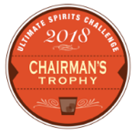
Pine Barrens American Single Malt Whisky: A fully finished Barley Wine English Ale Craft Beer that has been hopped to 70 IBU’s and is then aged in new American Oak Barrels. (Bottle 750mL: $65, 375mL: $39)
Rough Rider “Bull Moose” Three Barrel Rye Whisky: Rye aged in new American Oak, Ex-Bourbon Casks and Ex-Pine Barrens Casks. (Bottle 750mL: $39)
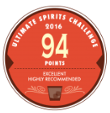
Rough Rider “The Big Stick”: Bottled at cask strength, this remarkable Rye reveals its true raw spirit with hints of spice coupled with malty sweetness, followed by a long warm finish. (Bottle 750mL $59)
Rough Rider Double Cask Straight Bourbon Whisky: Carefully aged in new American oak casks for a minimum of two years and extra matured in Ex-Brandy casks. Mash/Bill composition: 60% Corn, 33% Rye, 8% malted barley.
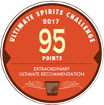
(Bottle 750ml: $39)
Pine Barrens Reserve Botanical Dry Gin: Our Deepwells Botanical Dry Gin, aged in Ex-Pine Barrens Single Malt Whisky Casks. (Bottle 750mL: $36)
Purchase any 4 mixed bottles and receive
Custom 4-pack bottle carrier and save $8 off your purchase

